Where to open an Eastern Asian Restaurant in Toronto?

Background
Toronto, the capital city of Ontario, the largest city in Canada, the fourth most popular city in North America, has a population of more than two million. With an annual average growth rate of 2.4% since 2009, Toronto’s Gross domestic product (GDP) has already reached CA$385.1 billion in 2016. With an extra boost from new investment in automotive manufacturing and a resurgence in immigration, the Greater Toronto Area is expected to have a growth of 4.5% in2021. Toronto has a strong restaurant industry. There are more than 8,100 restaurants, caterers, and bars and they generate$5.8 billion in revenues, which represents 6.5% of all businesses in Toronto. Torontonians also love to dine out. They dine out at an average of 3.1 times per week putting the city in the same rank as Chicago (2.8), New York City (3.0), and Las Vegas (3.3). The large population of immigrants from all over the globe has also made Toronto one of the most multicultural cities in the world. According to the 2016 census,51.5% of Toronto’s population is composed of visible minorities, compared to49.1% in 2011, and 13.6% in 1981. In terms of East Asian people, Chinese, Japanese and Korean accounts for 11.1%, 0.5%, and 1.5% of Toronto’s total population respectively

Business Problem
With the information given in the Introduction, one promising business opportunity is to open an Eastern Asian restaurant in Toronto. Thus, the aim of this report is to find ideal neighborhoods in Toronto to open an Eastern Asian restaurant. There are many important factors when choosing a location to open a restaurant. This report has considered population, ethnics, income, crimes, and nearby competitors of each neighborhood.

Data Acquisition and Cleaning
  - Data source
This report used following data sets. The first two data sets are extremely large and cover almost all demographic information required for this report. The third data source provides information for nearby competitive restaurants and the fourth data set provides the coordinates of each neighborhood in Toronto.
- Neighborhood Crime Rate, Toronto Police Service
- 2016 Neighborhood Profiles, Statistics Canada
- Foursquare API Venue Search, Foursquare developer
- Geo-spatial coordinates of neighborhoods in Toronto, Toronto City Government

  - Data Cleaning
Data mentioned in above are mostly formatted into .csv files. These files have missing information, redundant information, misplaced information, and format problems. This report has done the following data cleaning process and after data cleaning, required information are well present in Pandas DataFrames.
- The given geo-spatial coordinates of neighborhoods in Toronto have missing information. Totally, there are 140 neighborhoods in Toronto and only 104 coordinates are given. The missing coordinates of neighborhoods are manually searched and updated.
- The 2016 Neighborhood Profiles contains massive amount of detailed information for each neighborhood in respect of population, families, language, labor, housing, income, ethnic origin, education, and mobility. However, this report only requires information in respect of population, income, ethnic, and ethnic origin. Thus, certain data extraction is used to pull out useful information.
- In the .csv files of 2016 Neighborhood Profiles and Neighborhood Crime Rate, there are misplaced rows and certain values are not in correct format. In this report, numbers in .cvs files are converted to float type in Python and misplaced rows are relocated to the correct places.

  - Feature Collection
From Art gallery to Yoga studio, Foursquare API is able to return 180 unique categories of nearby venues. However, not all these categories can be considered as features. As the objective is to open an Easter Asian restaurant, only categories related to restaurant industries are considered as features. In terms of crimes, this report only consider crime types that frequently happen in restaurants. These crimes types are Assault, AutoThef, Breakand, Robbery and TheftOver. Other considered features are the average income, population, and ethnic origin.

Methodology and Analysis

This section firstly presents a visualization of all considered features then combine them together to generate a dataframe that used in K-Mean Clustering.
  - Features
The Figure 1 Toronto Overview briefly shows the neighborhoods distribution in Toronto. Totally there are 140 neighborhoods.
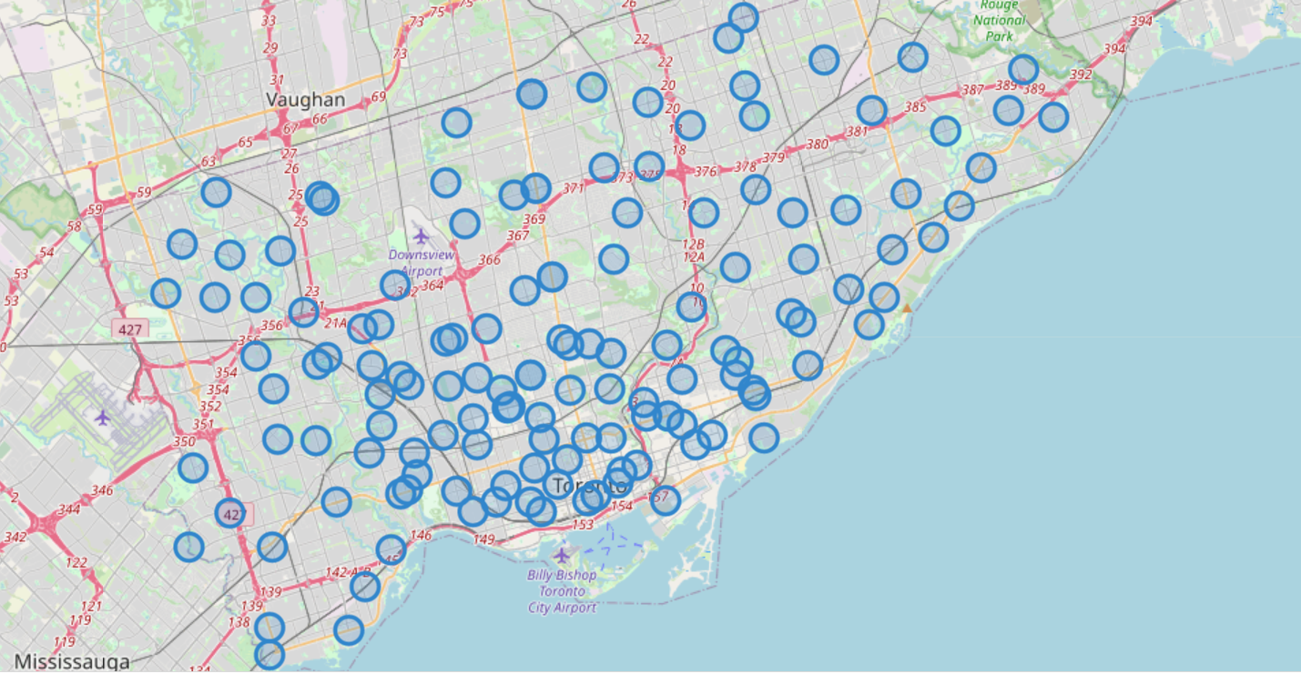
Figure 1 Toronto Overview

Population
The Figure 2 Population in each neighborhood shows the population in each neighborhood. There is one neighborhood that has a population more than 5700 and more than 30 neighborhoods have a population that less than 15000. The population density in Toronto is highly uneven.

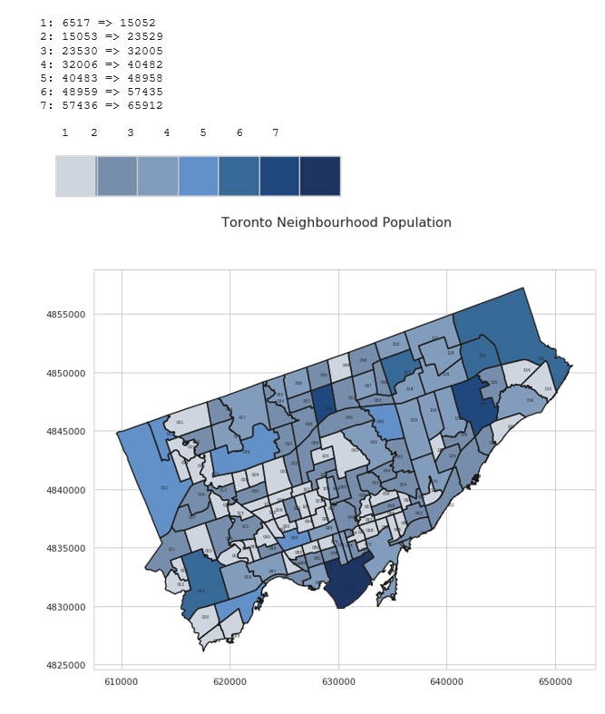
Figure 2 Population in each neighborhood

This report also investigate population in each age group and gender. Consider Figure 3, Figure 4 and Table 1. The most population in Toronto are in the working age group. It accounts for 44% of the total population. Toronto does not need to worry about population ageing for now. However, Toronto has 3.1% seniors than youth which is a sign for population ageing. Table 1 shows the first five row and the dataframe that describes the male and female population in each age group and Figure 4 is the visualization of Table 1. Female population have exceeded the male population from age group 25-29.
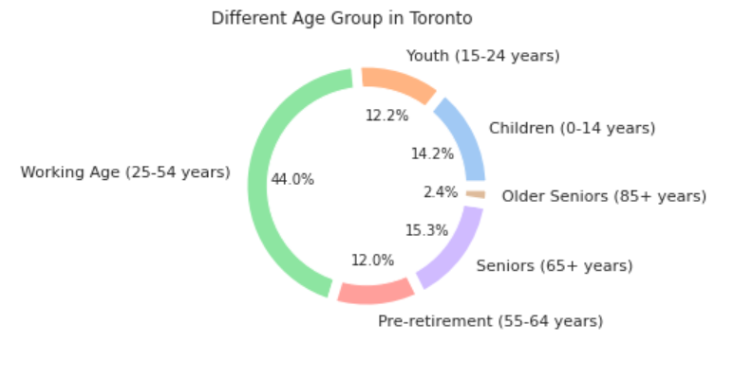
Figure 3

Table 1
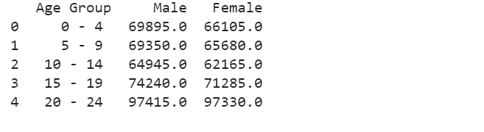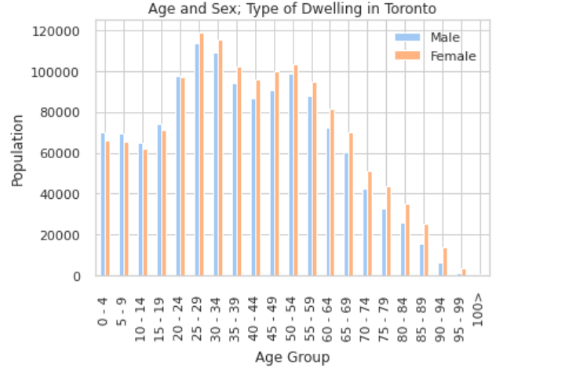

Figure 4

Crimes
This report also consider crime as a factor when choosing a location to open a restaurant. From the neighborhoods’ crime dataset, this report has considered crime types of Assault, AutoThef, Breakand, Robbery and Theft Over. The following Table 2 shows the average crime cases of the mentioned crime types and their percentage at each neighborhood. The Figure 5 shows the Choropleth Map of Table 2. From the choropleth map, it is can be seen that the neighbourhood ‘’ Waterfront Communities-The Island’ with most popluation also have the most number of crime cases. The good news is more than half of the neighbourhoods have less than 38 crime cases per year.
Table 2
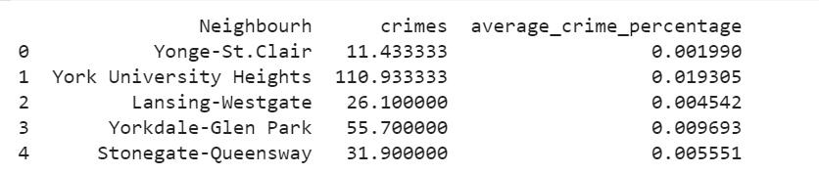

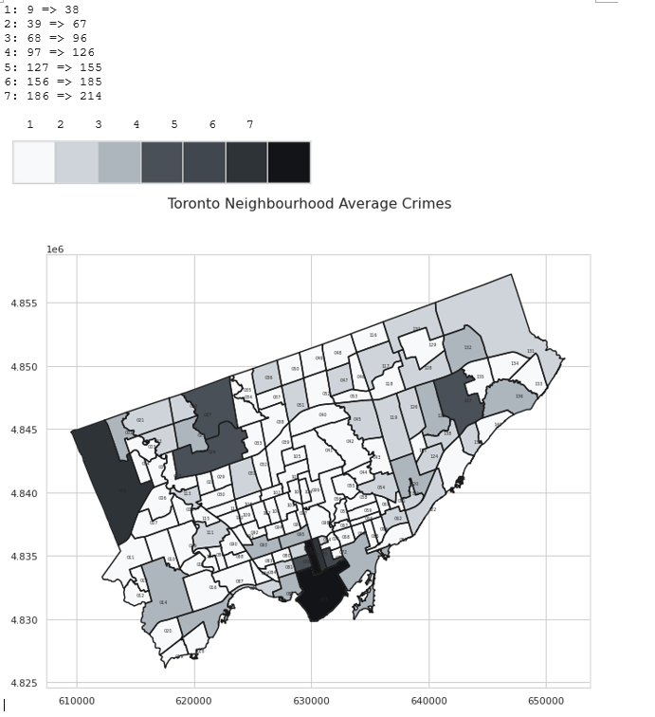
Figure 5

Income
The report also investigates the average income of each neighborhood. Consider the Table 3 and Figure 6 below. Table 3 shows the income percentage of each neighborhood and Figure 6 shows the choropleth map of average income. One interesting discover is that St.Andrew-Windfields is not the neighborhood with most population however, it has the highest average income.
Table 3
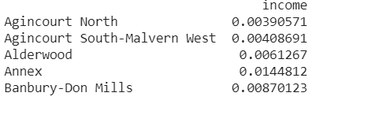
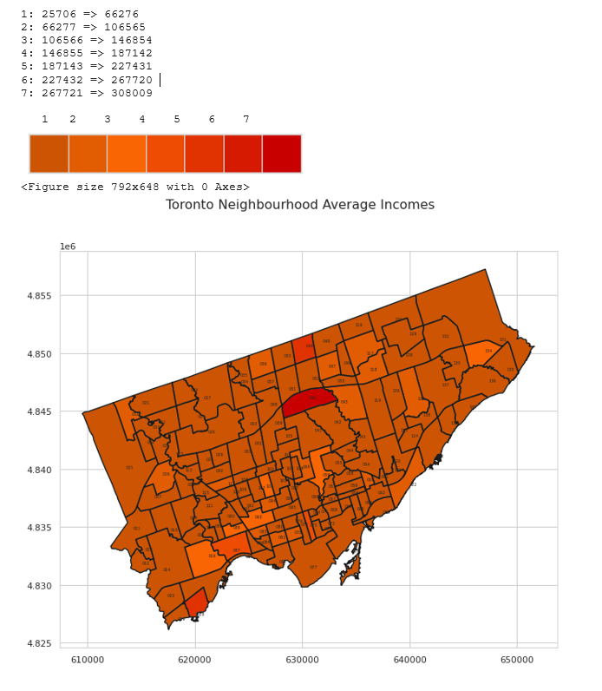
Figure 6

Ethnic Origins
As the objective is to open an Eastern Asian restaurant, this report especially considers the population of Chinese, Japanese and Korean. As the Figure is too large. Please click the hyperlink to see it.(Figure), it is also available on the Jupiter notebook. From the Figure, through all neighborhoods, Chinese population almost doubled or tripled the population of Japanese and Korean.

Foursquare API

To find a location for open a restaurant. The nearby competitors must be considered. Thus, this report uses Foursquare API to extract competitive restaurants. By giving the coordinates of all neighborhoods, the Foursquare API return the nearby venues in the radius of 2 kilometers. Then, this report selects out competitive restaurants such as Asian Restaurant, Chinese Restaurant, Hotpot restaurant and Ramen restaurant. After selected competitive restaurants, this report uses Foursquare API to calculate their ‘visit frequency’. See the Table 4 below as an example. In West Hill, only Indian restaurant and Xinjiang restaurant get positive ‘visit frequency’, other competitive restaurant have zero frequency. This indicates that rest competitive restaurant are not so popular in West Hill or there are no such restaurant in West Hill.
Table 4
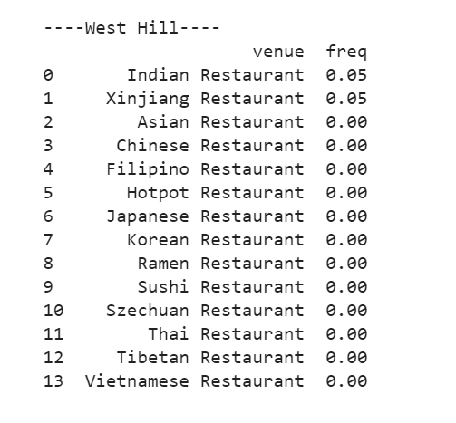

Final Data Frame
After considered features includes population, crimes, income, ethnic origins and competitive restaurants. This report formed the following dataframe Table 5 for K-mean Clustering.

Table 5
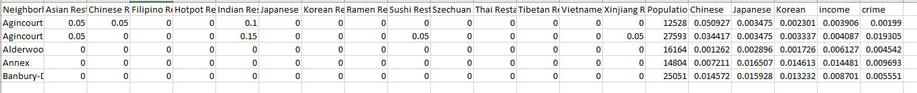

K-Mean Clustering
After collected all required features. We can perform K-Mean Clustering. We firstly use the elbow method to find the optimal number of K. From Figure 7 it can be seen that the optimal number of K should be around 6-10. In Figure 8, we have applied a visualization tool to help determine the optimal K. The cross point in Figure 8 shows that the optimal number of K is 8. Hence we are going to have 8 number of cluster.
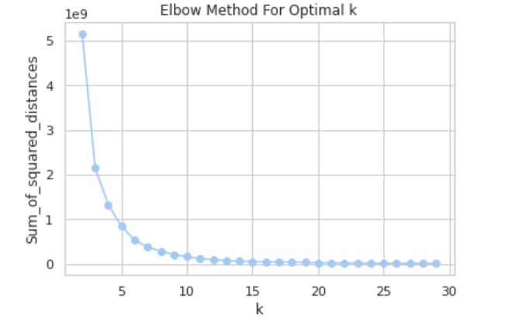
Figure 7

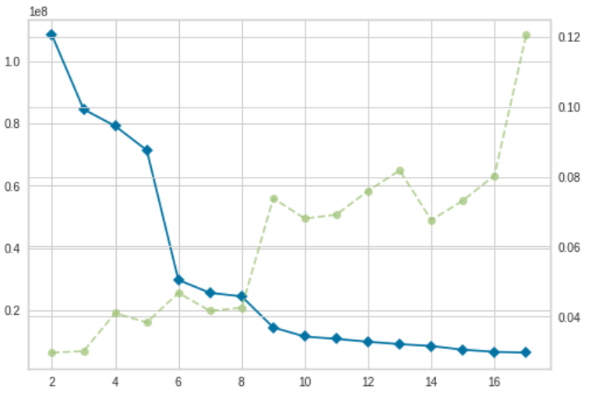
Figure 8
After the K Mean Clustering, we can have the cluster label for each neighborhood as Figure 9 shows below.
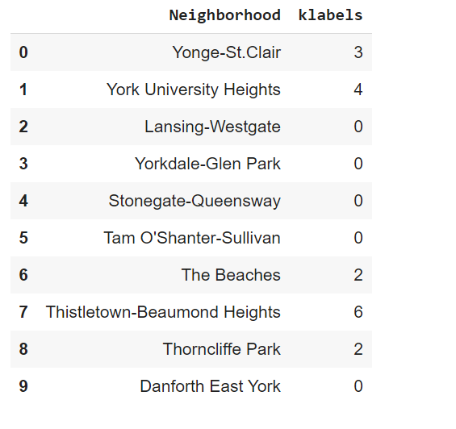
Figure 9
Figure 10 shows the cluster label of all neighborhoods.
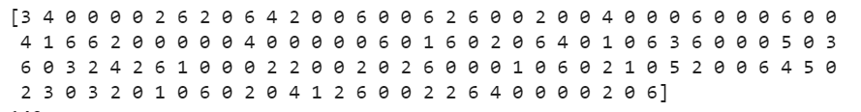
Figure 10

Evaluation
After K mean clustering, we want to know the common characteristic of neighborhoods in each cluster.

Cluster-0
We can see that neighborhoods in Cluster 0 have a lot of Japanese restaurant. However, other types of restaurants are not so popular.
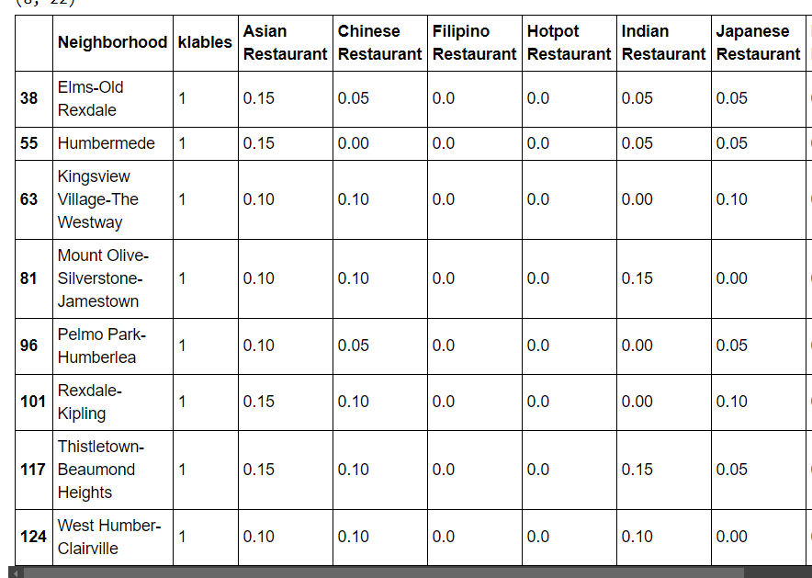

Cluster-1
Neighborhoods in Cluster 1 shows a strong preference for Chinese restaurant, Asian restaurant and Indian restaurant and some Japanese restaurant.

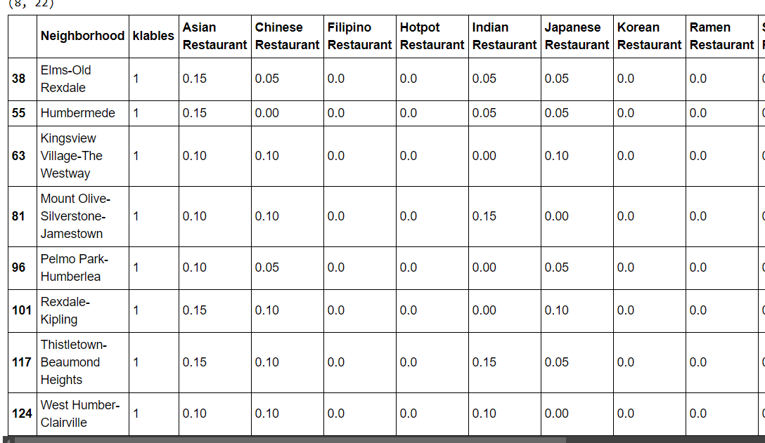

Cluster-2
Neighborhoods in Cluster 2 all prefer Thai Restaurants. At the same time, population in these neighborhoods are high. Most neighborhoods have a population more than 10000.
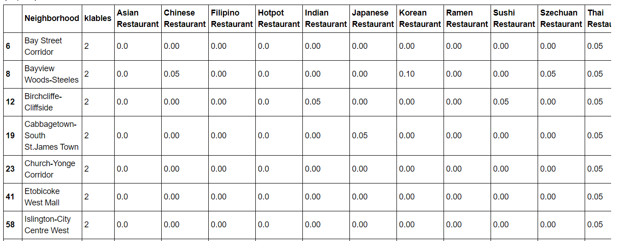
Cluster-3
Neighborhoods in Cluster3 has a strong preference for Xinjiang Restaurants and Indian restaurants and the residents incomes in these neighborhoods are stable around 0.004.
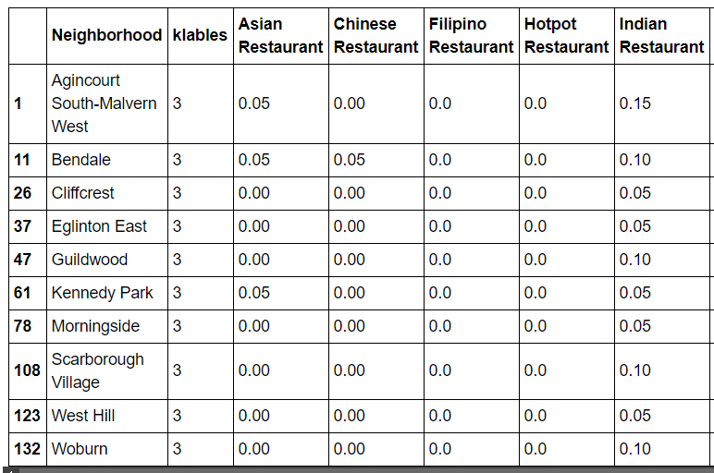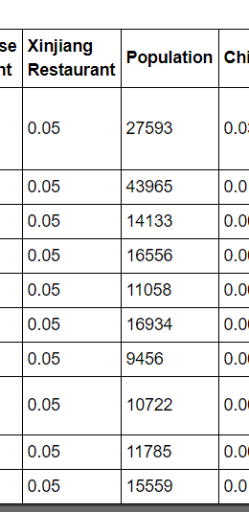

Cluster-4
Cluster 4 is a quite interesting cluster. It only contains four neighborhoods. Two neighborhoods show a strong preference for Japanese Restaurant, Ramen Restaurant and Thai Restaurant. They also have the highest number of residents with Japanese ethnics.
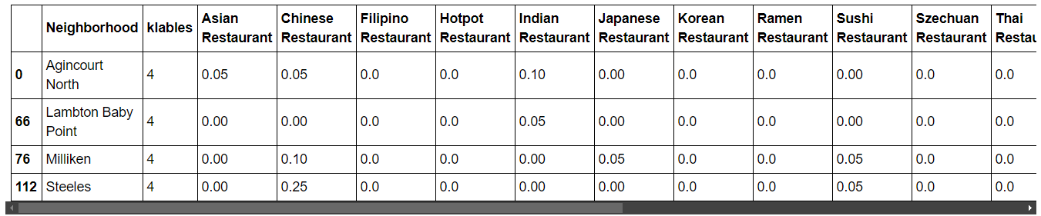
Cluster-5
Neighborhoods in Cluster 5 has a strong preference for Tibetan Restaurant and Japanese restaurant. However, the Chinese population are not the highest.
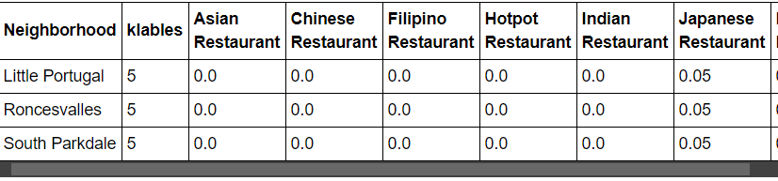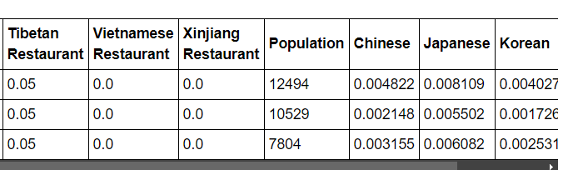
Cluster-6
Neighborhoods in cluster 6 shows a strong clear and strong preference for Japanese restaurant.
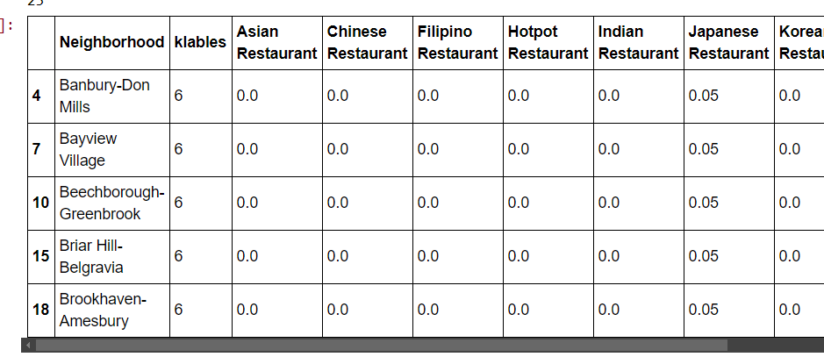

Conclusion
After investigated all cluster, we have colored labeled the neighborhoods.

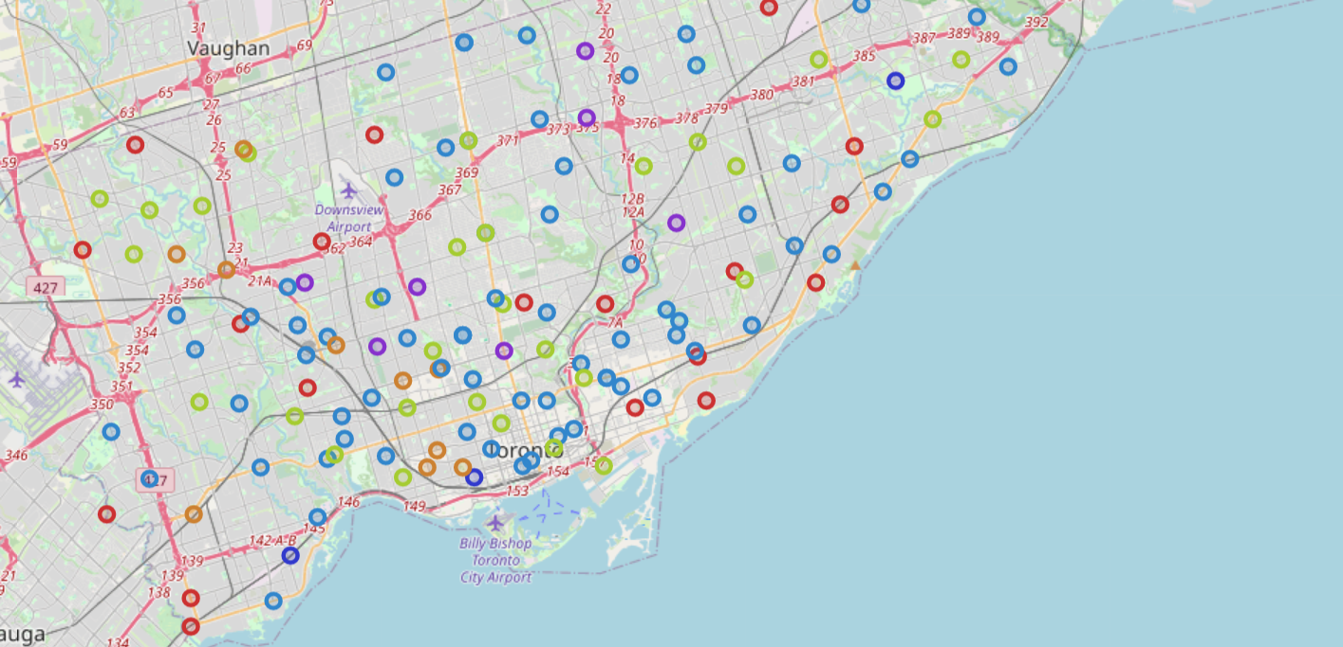

We recommend the following places to open a eastern Asian restaurant. These places are with high income population and fewer competitors.
0 Bay Street Corridor
1 Bayview Woods-Steeles
2 Cabbagetown-South St.James Town
3 Church-Yonge Corridor
4 Etobicoke West Mall
5 Islington-City Centre West
6 Mimico
7 Moss Park
8 Newtonbrook East
9 Newtonbrook West
10 North St.James Town
11 Oakridge
12 Regent Park
13 Rosedale-Moore Park
14 St.Andrew-Windfields
15 Taylor-Massey
16 Victoria Village
17 Westminster-Branson
18 Lansing-Westgate
19 Willowdale East
The following figures shows these selected neighborhoods.
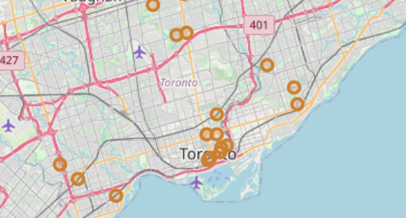
For future work, we may consider different machine learning algorithms and different features.

